NUCS 331 - Introduction to Computational Photography
Northwestern University
Winter 2022
Group: Fill in your group number/identifier
Names: Both of your names
NetIDs: Both of your netids
E-Mails: your.name@u.northwestern.edu
GitHub-Repo: http://www.YOURITHUBREPO.com
GitHub-Name: FILL IN YOUR GITHUB USERNAMES

Homework X - Title of Homework

Introduction
Please describe here - in your own words - what the assignment is about. A few questions that you can try to answer here are listed below
- What is the problem?
- Why is this problem important?
- How is the problem solved in the homework?
These questions are inspired by the Heilmaier Catechism, which you can read more about at these 2 links:
- https://www.darpa.mil/work-with-us/heilmeier-catechism
- https://rb.gy/n8xpsj
Please use short and understandable sentences. Better use two short sentences instead of one long, convoluted sentence. This is ’good practice’ of scientific writing as it is easier to understand for readers.

Questionnaire
2.1 Questions to answer - Report vs Think!
- In this section, you need to answer the questions listed at the end of the each homework in the Jupyter Notebook (the .ipynb file)
- IMPORTANT: There are more questions listed in between the programming assignments. You do not need to answer all of these questions in the report, as many of them are used to guide you to think about the problem
- Our recommendation: Try to think about all questions while you are working on the programming assignments (the .ipynb file). All questions that must be answered in the report will be repeated at the end of the Jupyter Notebook. Answer these questions after you have completed the programming assignment.

Writing practice
- Please use your own words to write the answer even if you find answers somewhere else, and don’t forget to cite the source. We will check for plagiarism.
- Some questions are open questions, just write what you think, please don’t write nothing for any question, as this can lead to failing the assignment.

Citations
In general, citing in LaTeX is much more convenient than in MS Word but it is also possible to do it in MS Word. Word has in-built support for adding a citation (References tab). Find more about it here: https://support.microsoft.com/en-us/office/add-citations-in-a-word-document-ab9322bb-a8d3-47f4-80c8-63c06779f127.
One way to do it is to add the required citations using “Insert Citation” (in “References” Tab). Whenever you want to cite a source, go to “Citations” (in the “References” Tab) and double-click to insert the required citation. The citation style (ex: IEEE) can be chosen before inserting the citation. At the end of the report, after Conclusion, insert the complete Bibliography using the “Bibliography” option in the “References” Tab. For more details refer to this link: https://support.microsoft.com/en-us/office/create-a-bibliography-citations-and-references-17686589-4824-4940-9c69-342c289fa2a5
In this template, we have actually inserted the citations as mentioned above, but if that’s a hassle, you can just type the number(s) inside square brackets and manually write out all the references at the end. You are also free to use any 3rd party extensions like Zotero or Mendeley which can simplify this process of citing and inserting bibliography.
To cite a specific paper, simply write [1] [2] or for a single citation Goossens et al [3]. For more information on how to cite a website or different citation styles, please look at the following link [4] https://owl.purdue.edu/owl/research_and_citation/resources.html .

Results
- In this section, you should include the important results of your programming implementations
- We will specify which results are important at the end of the homework, normally they are output images at various stages. You at least need to include those results in this section
- If there are other intermediate steps that you think are important, make sure to include them as well

Including Images
- Please make sure the images you include in the report are readable. Don’t make them too large or too small, and write appropriate captions.
- If there are axes, numbers or letters in the image, please adjust the font when you generate them so that readers can see them clearly. The font size of these elements should be at least the font size of the figure caption!
- For images with axes, please don’t forget to write the axes label. For images with color bars, please include the right value range. Then readers can understand the information of the image.
- We have shown a good and a bad example image in Figure 1
- Please write some explanation for each image you include in the report. Remember that when readers read your report, they may not understand the images unless you explain it in detail in the text.
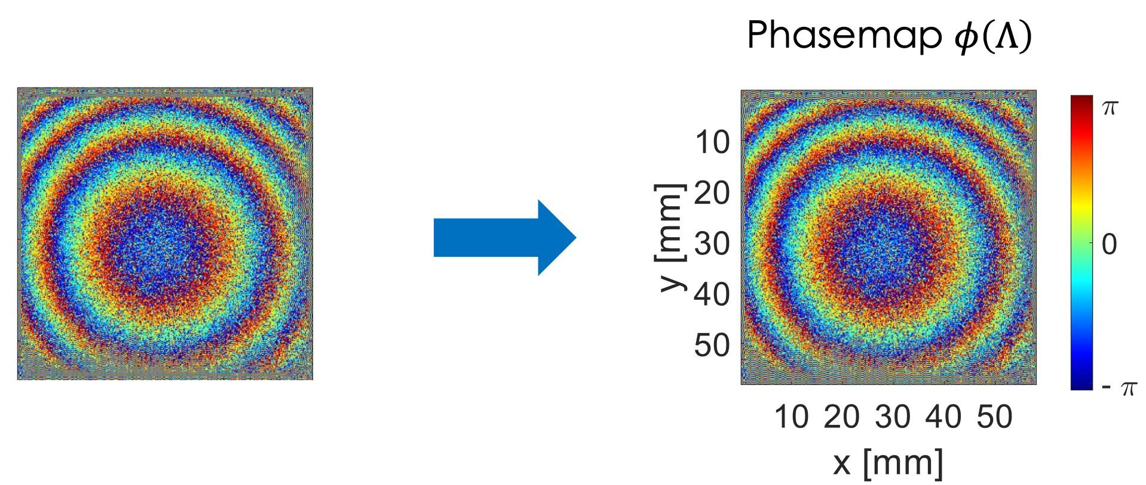
Figure 1: (Left) Example of a bad image (Right) good example image, make sure the size of color bar matches the size of the image, the text font size of these elements is at least the font size of the figure caption, you can always recompile to adjust it.

Conclusion
In this section, please use your own words to conclude what you have achieved in this homework and your further thinking of the problem

Bibliography

[1] | A. . Einstein|Perrett, “English translation: ‘On the Electrodynamics of Moving Bodies’,” Annalen der Physik, vol. 322, no. 10, p. , 1905.
[2] | “Knuth: Computers and Typesetting,” , . [Online]. Available: http://www-cs-faculty.stanford.edu/~uno/abcde.html#bugs. [Accessed 30 12 2021].
[3] | M. . Goossens and F. . Mittelbach, The LaTeX Companion, ed., vol. , , : Addison-Wesley, 2004, p. .
[4] | P. W. Lab, “Research and Citation Resources,” [Online]. Available: https://owl.purdue.edu/owl/research_and_citation/resources.html. [Accessed December 2021].

